For Immediate Release
WanaBana USA issues updated information on Voluntary Recall of WanaBana Apple Cinnamon Fruit Purée Pouches

November 30, 2023, USA--- In October of 2023, Wanabana USA was alerted by the U.S. Food and Drug Administration (“FDA”) that certain Apple Cinnamon fruit puree products manufactured by Austrofood and sold under the WanaBana brand in the United States tested positive for elevated levels of lead. Wanabana USA, the distributor of WanaBana products in the United States, promptly initiated a voluntary recall of all affected products from the market in coordination with FDA. Soon thereafter Austrofood added to the recall private-label Apple Cinnamon fruit puree products it manufactured for Weis and Schnucks.
Both Austrofood and Wanabana USA have been collaborating with the FDA in investigating the circumstances that led to this product recall. Based on the investigation to date, cinnamon appears to be the source of the elevated lead levels in the recalled products. In the interest of public health, Wanabana USA and Austrofoods are sharing that the cinnamon used in the recalled products was supplied by Negocios Asociados Mayoristas S.A., operating as Negasmart, a third-party company.
Austrofood and Wanabana USA have instituted a refund program that allows affected consumers to return recalled product at the point of sale for a full refund. The companies are also in the process of establishing a website that will allow consumers to submit requests for refunds directly to Austrofood and Wanabana USA. In addition, because the FDA has advised individuals who consumed the recalled products to contact a healthcare provider about getting a blood test for lead, Austrofood and Wanabana USA are in the process of establishing a program designed to reimburse users of the recalled products for documented out-of-pocket costs for healthcare provider visits and blood testing up to a set amount.
Austrofood and WanaBana USA will continue to update consumers with information related to this recall. Consumers with questions can email the company at support@wanabanafruits.com.
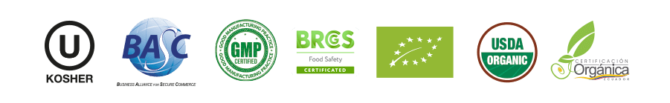
Media Contact: Karen Garnik, APR
E: karen@globalvisioncomms.com

